**PIZZA SALES SQL QUERIES**

1. **KPI’s**
2. **Total Revenue**

SELECT SUM(total_price) AS Total_Revenue FROM pizza_sales

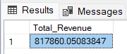

1. **Average Order Value**

SELECT SUM(total_price)/COUNT(DISTINCT(order_id)) AS Average_Order_Value FROM pizza_sales

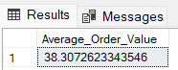

1. **Total Pizzas Sold**

SELECT SUM(quantity) AS Total_Pizzas_Sold FROM pizza_sales

1. **Total Orders**

SELECT COUNT(DISTINCT(order_id)) Total_orders FROM pizza_sales

1. **Average Pizzas per Order**

SELECT SUM(quantity)/COUNT(DISTINCT(order_id)) AS Average_Pizzas_Per_Order FROM pizza_sales

SELECT CAST(SUM(quantity) AS DECIMAL(10,2))/CAST(COUNT(DISTINCT(order_id)) AS DECIMAL(10,2)) AS Average_Pizzas_Per_Order FROM pizza_sales

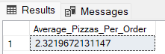

1. **Chart Requirement**
2. **Daily Trends for Total Orders**

SELECT DATENAME(w,order_date) AS Order_Day, COUNT(DISTINCT(order_id)) AS Total_Orders FROM pizza_sales

GROUP BY DATENAME(w,order_date)

1. **Monthly Trends for Total Orders**

SELECT DATENAME(m,order_date) AS Order_Month, COUNT(DISTINCT(order_id)) AS Total_Orders FROM pizza_sales

GROUP BY DATENAME(m,order_date)

1. **Percentage of Sales by Pizza Category**

SELECT pizza_category, CAST((SUM(total_price)*100)/(SELECT SUM(total_price) FROM pizza_sales) AS DECIMAL(10,2)) AS Percentage_Sales FROM pizza_sales

GROUP BY pizza_category

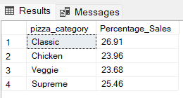

1. **Percentage of Sales by Pizza Category from January Month**

SELECT pizza_category, CAST((SUM(total_price)*100)/(SELECT SUM(total_price) FROM pizza_sales WHERE MONTH(order_date) = 1) AS DECIMAL(10,2)) AS Percentage_Sales FROM pizza_sales

WHERE MONTH(order_date) = 1

GROUP BY pizza_category

1. **Percentage of Sales by Pizza Size**

SELECT pizza_size, CAST((SUM(total_price)*100)/(SELECT SUM(total_price) FROM pizza_sales) AS DECIMAL(10,2)) AS Percentage_Sales FROM pizza_sales

GROUP BY pizza_size

ORDER BY Percentage_Sales DESC

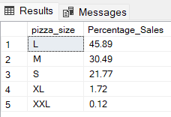

1. **Top 5 by Revenue**

SELECT TOP 5 pizza_name, CAST(SUM(total_price) AS DECIMAL(10,2)) AS Total_Revenue FROM pizza_sales

GROUP BY pizza_name

ORDER BY Total_Revenue DESC

1. **Bottom 5 by Revenue**

SELECT TOP 5 pizza_name, CAST(SUM(total_price) AS DECIMAL(10,2)) AS Total_Revenue FROM pizza_sales

GROUP BY pizza_name

ORDER BY Total_Revenue ASC

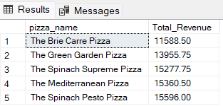

1. **Top 5 by Quantity**

SELECT TOP 5 pizza_name, SUM(quantity) AS Total_Quantity FROM pizza_sales

GROUP BY pizza_name

ORDER BY Total_Quantity DESC

1. **Bottom 5 by Quantity**

SELECT TOP 5 pizza_name, SUM(quantity) AS Total_Quantity FROM pizza_sales

GROUP BY pizza_name

ORDER BY Total_Quantity ASC

1. **Top 5 Pizzas wrt to order**

SELECT TOP 5 pizza_name, COUNT(DISTINCT(order_id)) AS Total_Orders FROM pizza_sales

GROUP BY pizza_name

ORDER BY Total_Orders DESC

1. **Bottom 5 Pizzas wrt to order**

SELECT TOP 5 pizza_name, COUNT(DISTINCT(order_id)) AS Total_Orders FROM pizza_sales

GROUP BY pizza_name

ORDER BY Total_Orders ASC

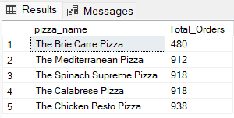

1. **Hello**